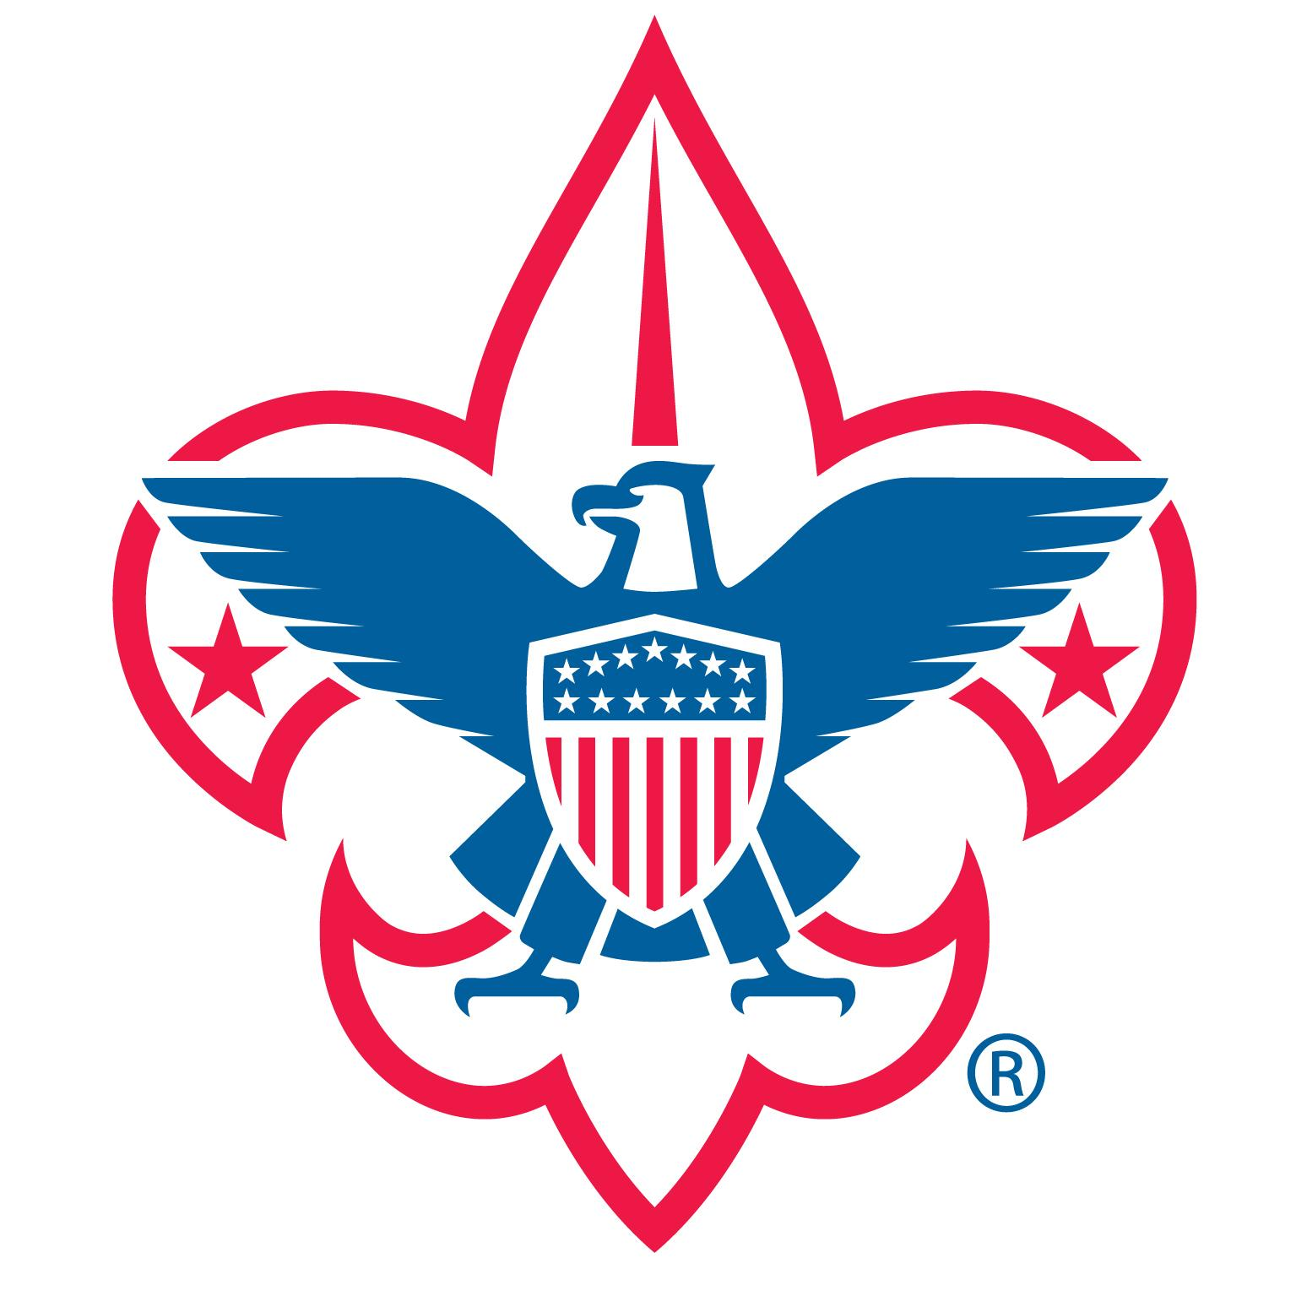
*Celebrate Earth Day–REDUCE, REUSE, RECYCLE

Boy Scout Troop 70
Annual Tag Sale Fundraiser

ONE COLLECTION WEEKEND ONLY!!!

Saturday, April 27 and
Sunday, April 28*
9 AM to 3 PM
MAKE YOUR TAX-DEDUCTIBLE DONATIONS at the NEW CANAAN RAILROAD PARKING LOT
Opposite Karl Chevrolet on Elm Street

Please donate your new or gently used items such as:
Artwork | Bikes | Boats & Kayaks | Cars | Cell Phones |Collectibles
Electronics | Flat Screen Monitors & TVs | Games
Hand & Power Tools | Holiday Items | Housewares
Indoor & Outdoor Children’s Toys |Jewelry | Lamps | Laptops/Computers
Lawn Equipment | Mirrors |Musical Instruments |Outdoor Furniture
Outdoor Grills |Small Antiques| Small Indoor Furniture | Snow Blowers
Sporting Goods | Strollers

WE ARE UNABLE TO ACCEPT:
Books, Backpacks, CDs, Clothing, Computer Bags, DVDs, Footwear,
Large Exercise Equipment (treadmills, weight sets, etc.),
Large Furniture, Luggage, Large Rugs, Linens, Stuffed Animals

TAG SALE on Saturday, May 4
9am – 2:30pm (8am Early Birds $10 entry fee)
St. Aloysius School Gym
Corner of South & Cherry Streets, New Canaan, CT
***Please do not call St. Aloysius Church***
For more information email: bsatroop70tagsale@gmail.com or visit www.newcanaanscouts.com

